Final Project Analysis

CRYSTAL CONTRERAS

DSC 423 Spring 2021

* Import dataset;

**DATA** bank;

INFILE "cleaned-bank.csv" FIRSTOBS=**2** DELIMITER=',';

INPUT i age job $ marital $ education $ default $ housing $ loan $ contact $ month $ day_of_week $ duration campaign pdays previous poutcome $ emp_var_rate cons_price_idx cons_conf_idx euribor3m nr_employed y $;

* Drop the index column from our data since it is not needed;

DROP i;

* Create dummy variables for categorical attributes;

job1=(job='blue-collar');

job2=(job='services');

job3=(job='admin.');

job4=(job='self-employed');

job5=(job='technician');

job6=(job='management');

job7=(job='retired');

job8=(job='entrepreneur');

job9=(job='housemaid');

job10=(job='unemployed');

job11=(job='student');

marital1=(marital='married');

marital2=(marital='single');

marital3=(marital='divorced'); * could also mean widowed;

ed0=(education='illiterate');

ed1=(education='basic.4y');

ed2=(education='basic.6y');

ed3=(education='basic.9y');

ed4=(education='high.school');

ed5=(education='professional.course');

ed6=(education='university.degree');

credit_default=(default='yes'); * 1 = yes, 0 = no;

housing_loan=(housing='yes');

has_loan=(loan='yes');

cellphone=(contact='cellular'); * 0 = telephone;

* survey conducted between March - December;

month3=(month='mar');

month4=(month='apr');

month5=(month='may');

month6=(month='jun');

month7=(month='jul');

month8=(month='aug');

month9=(month='sep');

month10=(month='oct');

month11=(month='nov');

month12=(month='dec');

day1=(day_of_week='mon');

day2=(day_of_week='tue');

day3=(day_of_week='wed');

day4=(day_of_week='thu');

day5=(day_of_week='fri');

prev_outcome1=(poutcome='failure');

prev_outcome2=(poutcome='nonexistent');

prev_outcome3=(poutcome='success');

target=(y='yes');

**RUN**;

**PROC** **PRINT**;

**RUN**;

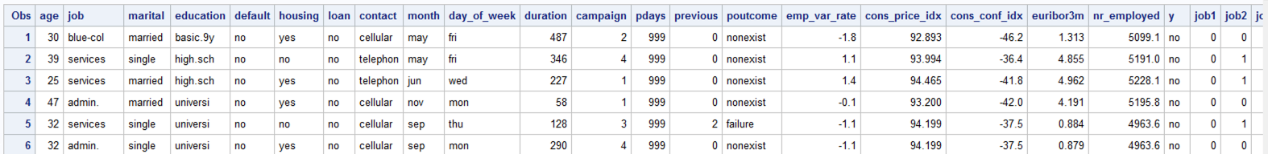

* Create a copy of the dataset that omits duplicate attributes - the ones we created dummy variables for;

**DATA** bank_new;

SET bank;

DROP job marital education month default housing loan contact day_of_week poutcome y;

**RUN**;

TITLE "Bank New";

**PROC** **PRINT**;

**RUN**;

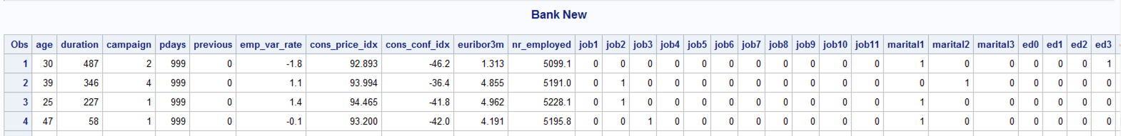

* Check the frequency of our target variable to ensure we have enough samples of each side;

**PROC** **FREQ**;

TITLE "Dependent Variable's Frequency";

TABLES target;

**RUN**;

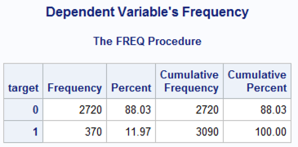

We have 2720 samples of 'no' = 88% Probability, and 370 samples of 'yes' = 12% Probability.

odds(y=1) = 0.12/0.88 => The odds that event Y = 1 occurs is 0.136 to 1. This means we have a higher chance of failure.

odds(y=0) = 0.88/0.12 => 7.33 to 1 (slide 8 of lecture 7)

I predict this will affect our Probability, threshold, train/test split.

1. Find out what percentage of each Y value we should have in relation to our dataset.

- Slide 35 of Lecture 7 states 10-30 cases per independent variable. 53 (w/dummy) * 10 = 530 observations we should have.

" - Make sure it has enough observations for each case (1 & 0).

If there isn't enough samples or there are many cells with no response,

parameter estimates and standard errors are likely to be unstable & maximum likelihood estimation

(MLE) of parameters could be impossible to obtain."

2. Either remove some observations of 'no', add in more 'yes' samples, or both.

Check the following:

1. is the Y variable binary?
2. Is there enough samples?
   1. What is the sample size n?
   2. How many predictors are there (k)?
   3. How many observations have Y=1 & y=0?
   4. Do we have enough sample (sample/k=10+)?

* Run Logistic Regression on the full model;

**PROC** **LOGISTIC**;

TITLE "Logistic Regression on Full Model";

MODEL target (event='1') = age duration campaign pdays previous emp_var_rate cons_price_idx cons_conf_idx euribor3m nr_employed job1 job2 job3 job4 job5 job6 job7 job8 job9 job10 job11 marital1 marital2 marital3 ed0 ed1 ed2 ed3 ed4 ed5 ed6 credit_default housing_loan has_loan cellphone month3 month4 month5 month6 month7 month8 month9 month10 month11 month12 day1 day2 day3 day4 day5 prev_outcome1 prev_outcome2 prev_outcome3 / STB RSQUARE;

**RUN**;

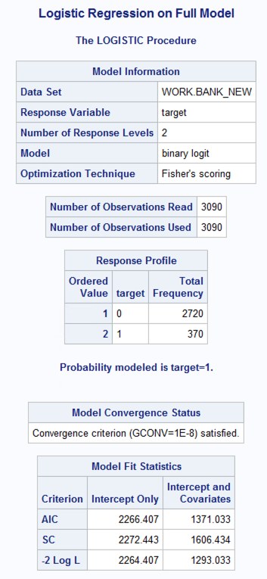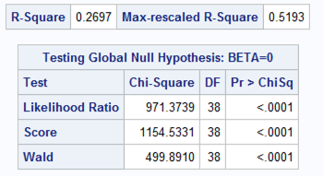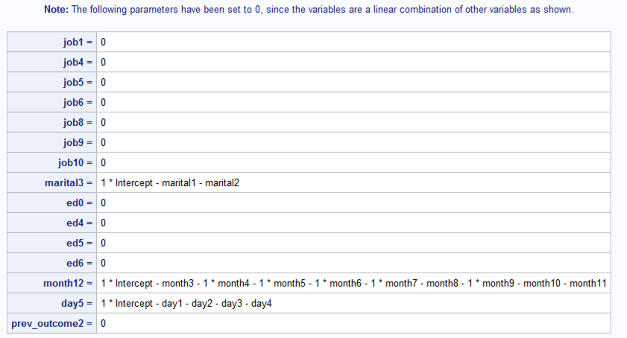

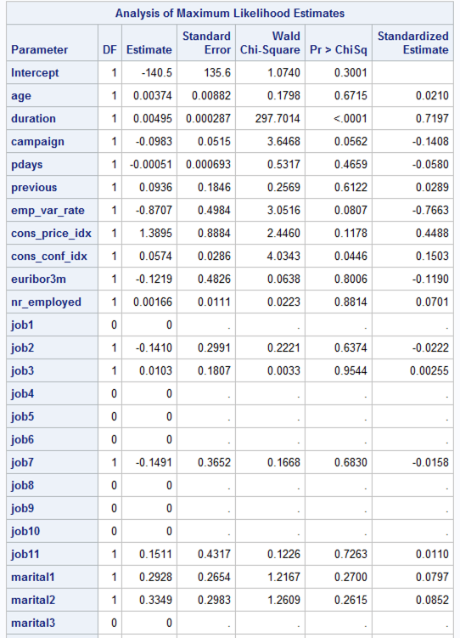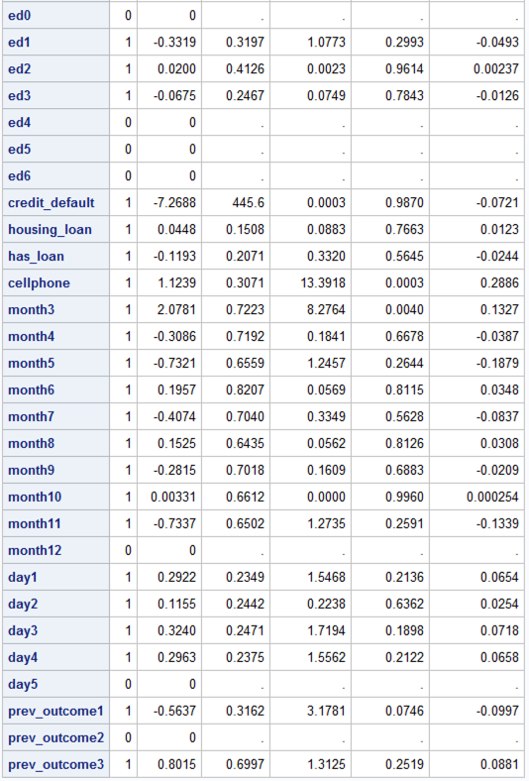

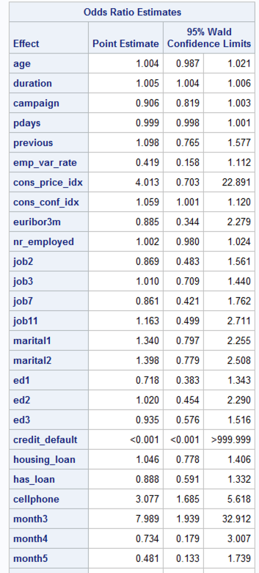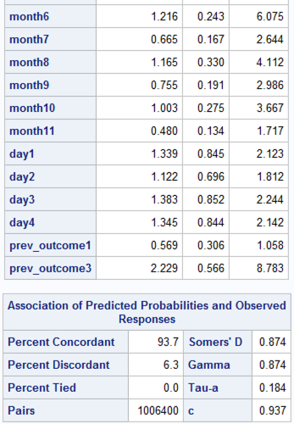

Do we also need to write the general model equation?

Fit the full model with standardized coefficients.

1. Which variables have the highest influence?
   1. Duration, 0.7197
   2. Second highest influence: emp_var_rate, -0.7663
2. Which vars have sig effect on odd of Y=1?
   1. Credit_default: -7.2688
   2. 2nd highest sig effect: month3: 2.078
3. Were any of the highest influential predictors insignificant?
   1. No. the top 2 predictors with the highest influence were not considered insignif.
4. Write full model equation

log(target=1/target=0) = -140.5 + 0.00374*AGE + 0.00495*DURATION – 0.0983*CAMPAIGN – 0.00051*PDAYS + 0.0936*PREVIOUS – 0.8707*EMP_VAR_RATE + 1.3895*CONS_PRICE_IDX + 0.0574*CONS_CONF_IDX – 0.1219*EURIBOR3M + 0.00166*NR_EMPLOYED + 0*JOB1 – 0.140*JOB2 + 0.0103*JOB3 + 0*JOB4 + 0*JOB5 + 0*JOB6 -0.1491*JOB7 + 0*JOB8 + 0*JOB9 + 0*JOB10 + 0.1511*JOB11 + 0.2928*MARITAL1 + 0.3349*MARITAL2 + 0*MARITAL3 + 0*ED0 – 0.3319*ED1 + 0.02*ED2 – 0.0675*ED3 + 0*ED4 + 0*ED5 + 0*ED6 – 7.2688*CREDIT_DEFAULT + 0.0448*HOUSING_LOAN – 0.1193*HAS_LOAN + 1.1239*CELLPHONE + 2.0781*MONTH3 – 0.3086*MONTH4 - 0.7321*MONTH5 + 0.1957*MONTH6 – 0.4074*MONTH7 + 0.1525*MONTH8 – 0.2815*MONTH9 + 0.003*MONTH10 – 0.73*MONTH11 + 0*MONTH12 + 0.2922*DAY1 + 0.1155*DAY2 + 0.3240*DAY3 + 0.2963*DAY4 + 0*DAY5 – 0.5637*PREV_OUTCOME1 + 0*PREV_OUTCOME2 + 0.8015*PREV_OUTCOME3

Where job1=1 when job='blue-collar',

job2=1 when job='services',

job3=1 when job='admin.',

job4=1 when job='self-employed',

job5=1 when job='technician',

job6=1 when job='management',

job7=1 when job='retired',

job8=1 when job='entrepreneur',

job9=1 when job='housemaid',

job10=1 when job='unemployed',

job11=1 when job='student',

marital1=1 when marital='married',

marital2=1 when marital='single',

marital3=1 when marital='divorced' (which could also mean widowed),

ed0=1 when education='illiterate',

ed1=1 when education='basic.4y',

ed2=1 when education='basic.6y',

ed3=1 when education='basic.9y',

ed4=1 when education='high.school',

ed5=1 when education='professional.course',

ed6=1 when education='university.degree',

credit_default=1 when default='yes',

housing_loan=1 when housing='yes',

has_loan=1 when loan='yes',

cellphone=1 when contact='cellular',

cellphone=0 when contact=‘telephone’,

month3=1 when month='mar',

month4=1 when month='apr',

month5=1 when month='may',

month6=1 when month='jun',

month7=1 when month='jul',

month8=1 when month='aug',

month9=1 when month='sep',

month10=1 when month='oct',

month11=1 when month='nov',

month12=1 when month='dec',

day1=1 when day_of_week='mon',

day2=1 when day_of_week='tue',

day3=1 when day_of_week='wed',

day4=1 when day_of_week='thu',

day5=1 when day_of_week='fri',

prev_outcome1=1 when poutcome='failure',

prev_outcome2=1 when poutcome='nonexistent',

prev_outcome3=1 when poutcome='success',

target=1 when y='yes'.

R-SQUARE = 0.2697 (Want highest)

AIC = 1371.033 (Want lowest)

SC = 1606.434 (Want lowest)

Likelihood Ratio (LR) = 971.3739 (Want highest)

For AIC & SC, we compare their ‘Intercept & Covariates’ values against each model.

LR used for GOF Test. Similar to F-test. Tests Global Null Hypothesis. P-value associated with it is < .0001. Reject H0. The predictors can significantly predict the outcome of Y=1. (Lecture 7, slide 32).

* Explore data to check for multicollinearity amongst independent, non-categorical variables;

**PROC** **CORR**;

TITLE "Pearson Correlation Coefficients of Independent Variables";

VAR age duration campaign pdays previous emp_var_rate cons_price_idx cons_conf_idx euribor3m nr_employed;

**RUN**;

Results:

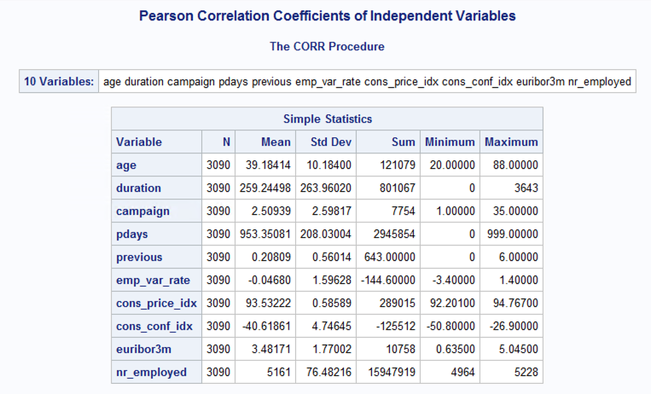

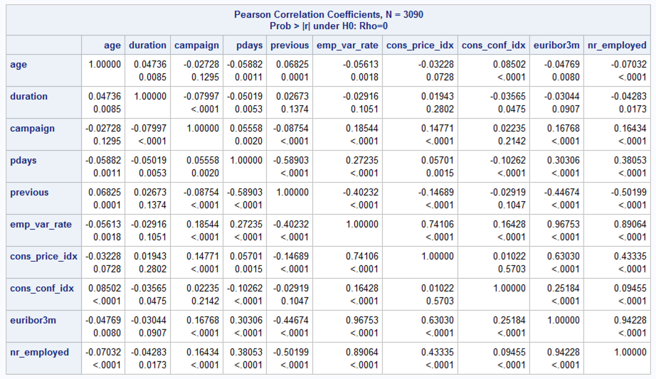

EURIBOR3M & EMP_VAR_RATE have a Pearson correlation coefficient of 0.96753.

EURIBOR3M & NR_EMPLOYED have a Pearson correlation coefficient of 0.94228.

NR_EMPLOYED & EMP_VAR_RATE have a Pearson correlation coefficient of 0.89064.

* Run a selection method for logistic regression;

**PROC** **LOGISTIC**;

TITLE "Backwards selection method";

MODEL target (event='1') = age duration campaign pdays previous emp_var_rate cons_price_idx cons_conf_idx euribor3m nr_employed job1 job2 job3 job4 job5 job6 job7 job8 job9 job10 job11 marital1 marital2 marital3 ed0 ed1 ed2 ed3 ed4 ed5 ed6 credit_default housing_loan has_loan cellphone month3 month4 month5 month6 month7 month8 month9 month10 month11 month12 day1 day2 day3 day4 day5 prev_outcome1 prev_outcome2 prev_outcome3 / SELECTION=BACKWARD RSQUARE STB;

**RUN**;

Backwards selection chose: DURATION, EMP_VAR_RATE, CONS_PRICE_IDX, CONS_CONF_IDX, CELLPHONE, MONTH3, MONTH6, MONTH8, PREV_OUTCOME3

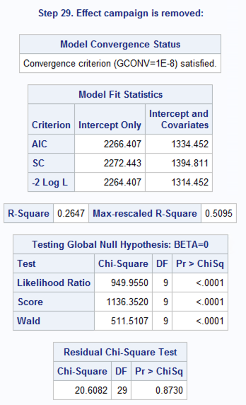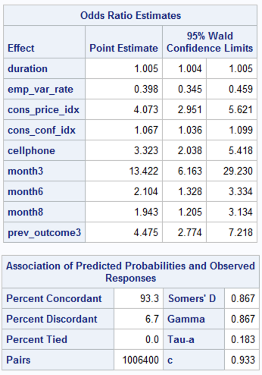 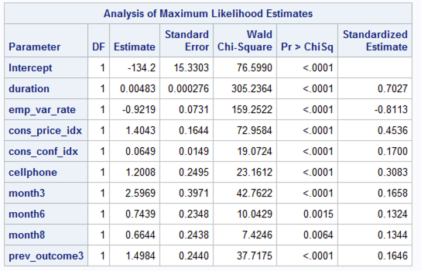

* Run a selection method for logistic regression;

**PROC** **LOGISTIC**;

TITLE "Stepwise selection method";

MODEL target (event='1') = age duration campaign pdays previous emp_var_rate cons_price_idx cons_conf_idx euribor3m nr_employed job1 job2 job3 job4 job5 job6 job7 job8 job9 job10 job11 marital1 marital2 marital3 ed0 ed1 ed2 ed3 ed4 ed5 ed6 credit_default housing_loan has_loan cellphone month3 month4 month5 month6 month7 month8 month9 month10 month11 month12 day1 day2 day3 day4 day5 prev_outcome1 prev_outcome2 prev_outcome3 / SELECTION=STEPWISE RSQUARE STB;

**RUN**;

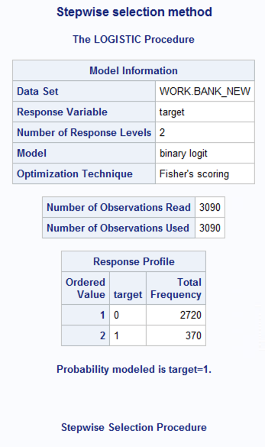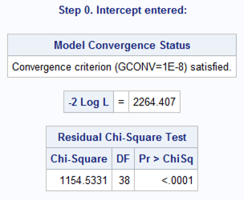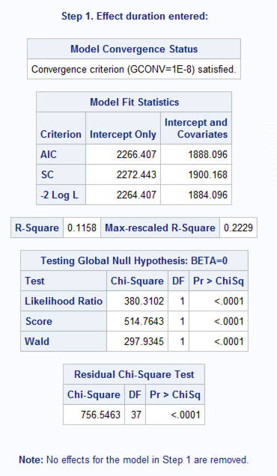

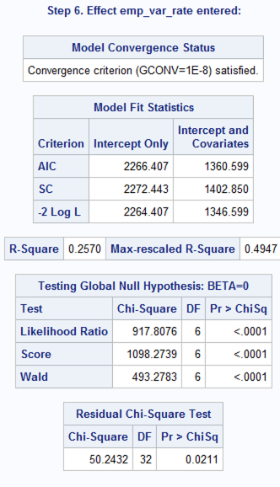 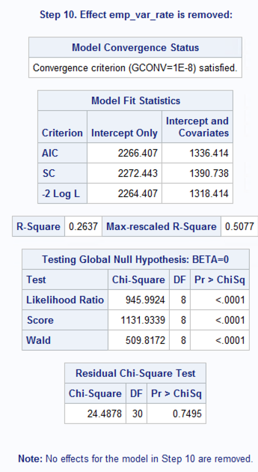

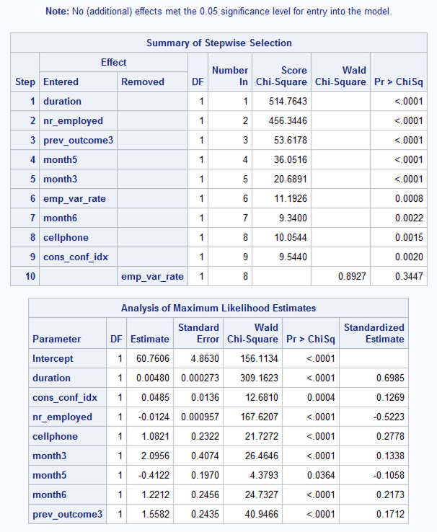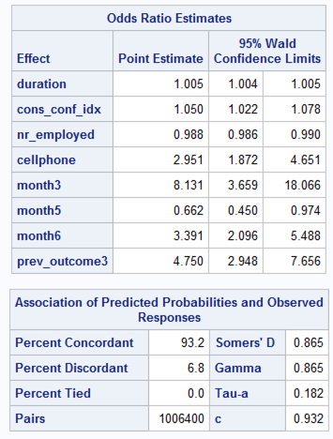

Stepwise selection model chose: DURATION, CONS_CONF_IDX, NR_EMPLOYED, CELLPHONE, MONTH3, MONTH5, MONTH6, PREV_OUTCOME3

RSQUARE = 0.2637

Month5 (May) was seen as significant in the STEPWISE selection method.

This is biased because it's the month with the most calls.

Month3 (March) followed as significant. It has the 2nd lowest frequency (good thing),

but it's also the 1st month of the campaign. Finally, month6 (June) followed as significant.

This month may also be biased because it has the 2nd highest frequency of calls.

The stepwise selection method chose 8 out of the 53 attributes, but the R2 value was only 0.2637.

I want to test if removing some observations would increase the Rsquare value,

specifically observations that meet the following criteria:

- target = 0

- pdays = 999 (b/c 95% of our data is comprised of those values)

- month = 'may' (month w/the highest amount of calls)

Another option could be to add in more 'yes' samples from the full dataset to add

more variance and increase the probability that event Y will occur.

Use stepwise and backward selection methods. Compare the 2 methods.

1. Did both of them select the same predictors?

Backwards selection chose: DURATION, EMP_VAR_RATE, CONS_PRICE_IDX, CONS_CONF_IDX, CELLPHONE, MONTH3, MONTH6, MONTH8, PREV_OUTCOME3

Stepwise selection model chose: DURATION, CONS_CONF_IDX, NR_EMPLOYED, CELLPHONE, MONTH3, MONTH5, MONTH6, PREV_OUTCOME3

Note:

EURIBOR3M & EMP_VAR_RATE have a Pearson correlation coefficient of 0.96753.

EURIBOR3M & NR_EMPLOYED have a Pearson correlation coefficient of 0.94228.

NR_EMPLOYED & EMP_VAR_RATE have a Pearson correlation coefficient of 0.89064.

1. Did they select the identical models (i.e. same parameter estimates, CI)?

|  |  |  |  |  |
| --- | --- | --- | --- | --- |
| Parameter Estimates |  |  | Backwards | Stepwise |
| Intercept |  |  | -134.2 | 60.76 |
| DURATION |  |  | 0.00483 | 0.0048 |
| EMP_VAR_RATE |  |  | -0.9219 |  |
| CONS_PRICE_IDX | |  | 1.4043 |  |
| CONS_CONF_IDX | |  | 0.0649 | 0.0485 |
| CELLPHONE |  |  | 1.2008 | 1.0821 |
| MONTH3 |  |  | 2.5969 | 2.0956 |
| MONTH5 |  |  |  | -0.4122 |
| MONTH6 |  |  | 0.7439 | 1.2212 |
| MONTH8 |  |  | 0.6644 |  |
| NR_EMPLOYED |  |  |  | -0.0124 |
| PREV_OUTCOME3 | |  | 1.4984 | 1.5582 |

Backwards:  
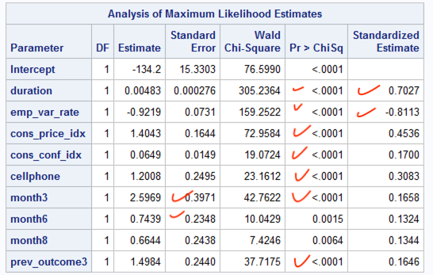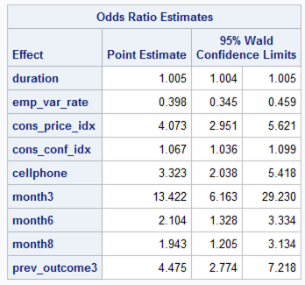

Stepwise:  
 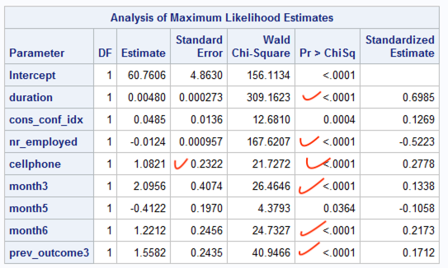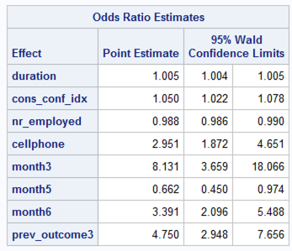

Based on the following metrics, the variables selected by Backwards selection returned the better model to use:

|  |  |  |  |  |
| --- | --- | --- | --- | --- |
|  |  | Full Model | Backwards Selection Method | Stepwise Selection Method |
| highest | RSQUARE | 0.2697 | 0.2647 | 0.2637 |
| lowest | AIC | 1371.033 | 1334.452 | 1336.414 |
| lowest | SC | 1606.434 | 1394.811 | 1390.738 |
| highest | LR | 971.3739 | 1314.452 | 945.9924 |
|  |  |  |  |  |
| (Most Influential Predictors) Standardized Estimates for: |  |  |  |  |
| EMP_VAR_RATE |  | -0.7663 | -0.8113 |  |
| CONS_PRICE_IDX | | 0.4488 | 0.4536 | -0.1269 |
| MONTH5 |  | -0.1879 |  | -0.1058 |
| MONTH8 |  | 0.0308 | 0.1344 |  |
| NR_EMPLOYED |  | 0.0701 |  | -0.5223 |

Fit the final model to check the following

* Run Logistic Regression on the selected variables;

* Check for multicollinearity - Pearson Correlation;

* Requires CORRB option at the end of PROC LOGISTIC MODEL;

* Check for outliers - Pearson or Deviance Residuals +-3;

* Requires IPLOTS option;

* Check for influential points - DFBetas;

* Requires INFLUENCE option;

**PROC** **LOGISTIC**;

TITLE "Logistic Regression on Backward selection method's predictors";

MODEL target (event='1') = duration emp_var_rate cons_price_idx cons_conf_idx cellphone month3 month6 month8 prev_outcome3 / RSQUARE STB CORRB IPLOTS INFLUENCE;

**RUN**;

1. Are there multicollinearity among predictors that are in the final model?

In order to check for multicollinearity, we used the CORRB option in our Logistic Regression’s MODEL statement, which checks “the correlation of the coefficients of these variables in the model” (Slide 40, lecture 7).

The final model does not present multicollinearity among predictors. All the predictors selected have a correlation value of < 0.7.

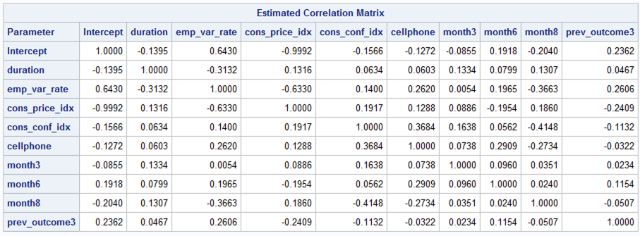

1. Are there influential points and outliers?

outliers:

Observation 1093, 1012, 1119, 1323, 1448, 1499, 1500, 1580, 1693, 1797, 3082

Found these based on Pearson Residuals & Deviance Residual values.

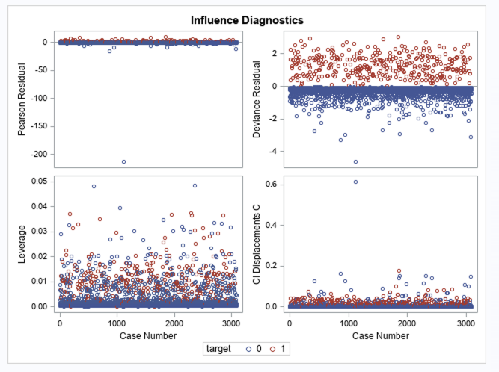

For influential points, we checked the DFBETA values.

n=3090 | Dfbeta | > 2/sqrt(n) | Dfbeta | > 2/sqrt(3090) ≈ 0.036

I think we have too many observations, which makes it harder to check for influential points. According to our formula, it would seem as though most of our observations would be considered influential points.

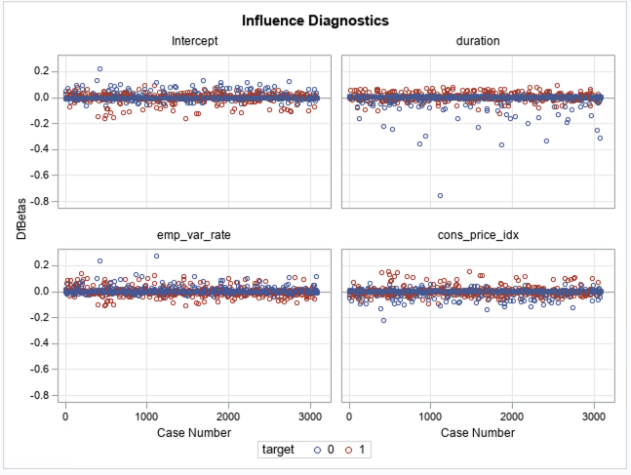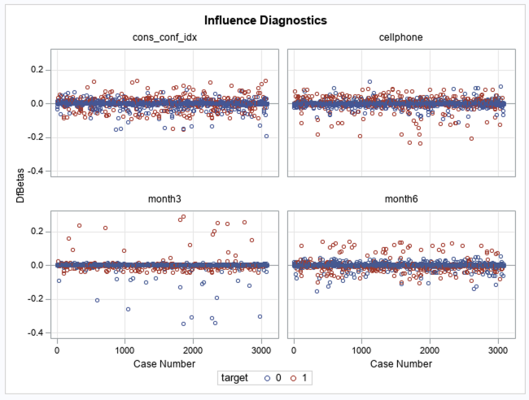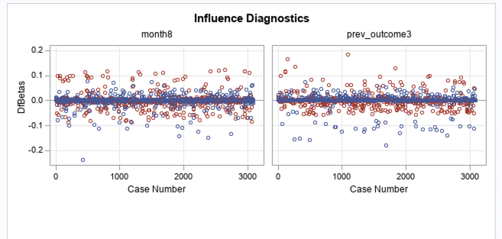

1. If you see collinearity among predictors what actions would you take?

Since no collinearity existed among predictors, no actions were taken.

1. If you see influential points or outliers, what actions would you take?

Since we have an abundance of data points, we removed all *outliers* with Pearson & Deviance Residuals > 3.

New N = 3079, y=0 = 2716, 1 = 363. The RSQUARE, AIC, SC, & LR improved.

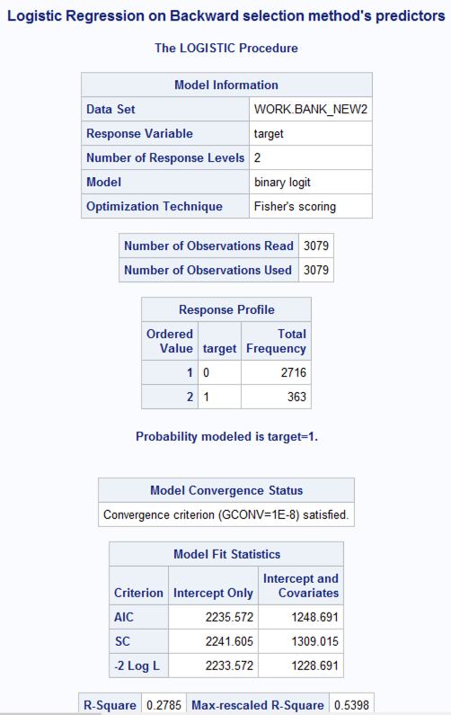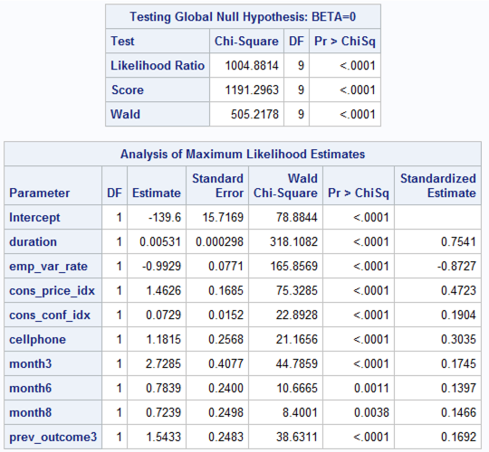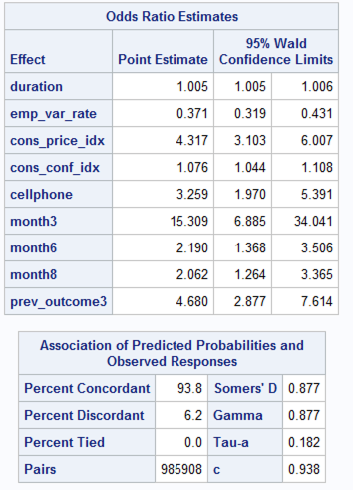

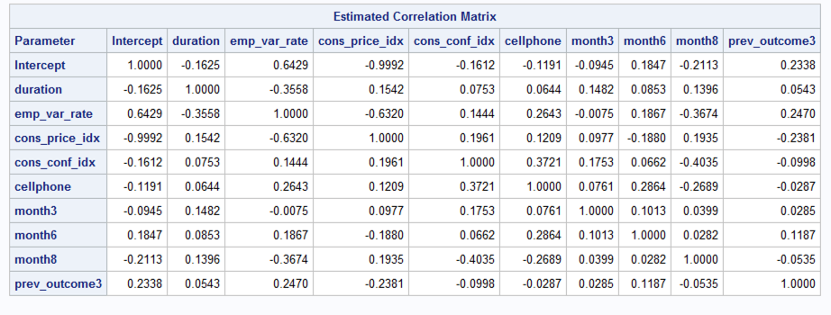

Still at least 5-8 outliers in observations:

2 that are <1000

Observations: 531, 712, 860, 940, 1835, 1860

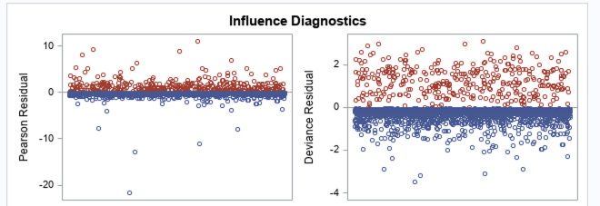

Note: Don’t remove IPs for dummy variables, which in this case are MONTH3, MONTH6, MONTH8, & PREV_OUTCOME3

END ANALYSIS OF ALL OBSERVATIONS (3,090 DATASET)

TESTING ON A SMALLER SUBSET OF OUR DATASET

We decided to test a smaller dataset’s effect on our model. Since 88% of our dataset consisted of Y=0, we removed 2000 records that had a dependent variable = ‘no’ & pdays = 999 (the equivalent of null). This reduced our dataset to 1,090 records & decreased our Y=0 to 66% & Y=1 to 34%. This improved our model’s accuracy statistics by *reducing the standard errors & creating more stable parameter estimates*.

Next, we created a correlation matrix to observe variable relationships.

EURIBOR3M & EMP_VAR_RATE have a Pearson correlation coefficient of 0.96.

EURIBOR3M & NR_EMPLOYED have a Pearson correlation coefficient of 0.94.

NR_EMPLOYED & EMP_VAR_RATE have a Pearson correlation coefficient of 0.87.

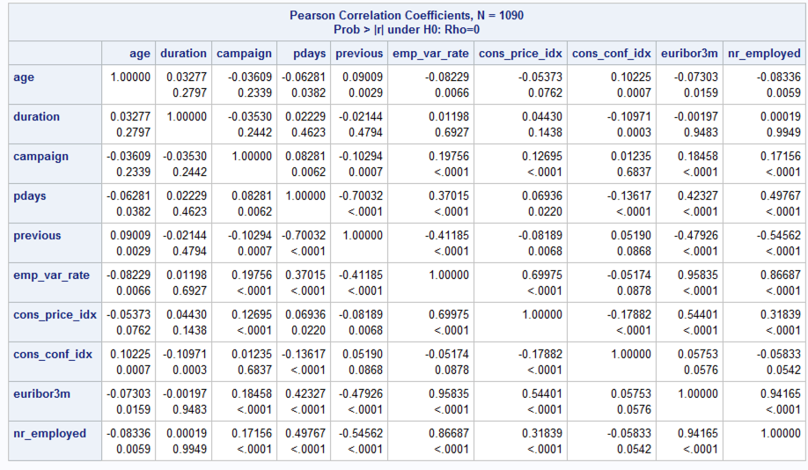

Next, we ran the logistic model on the full model for this new subset.

log(target=1/target=0) = -401.3 + 0.0136*AGE + 0.006*DURATION – 0.117*CAMPAIGN + 0.0015*PDAYS + 0.276*PREVIOUS – 1.759 *EMP_VAR_RATE + 3.16 *CONS_PRICE_IDX + 0.08*CONS_CONF_IDX – 0.55*EURIBOR3M + 0.02*NR_EMPLOYED + 0*JOB1 – 0.21*JOB2 0.09*JOB3 + 0*JOB4 + 0*JOB5 + 0*JOB6 -0.47*JOB7 + 0*JOB8 + 0*JOB9 + 0*JOB10 - 0.0009*JOB11 + 0.48*MARITAL1 + 0.63*MARITAL2 + 0*MARITAL3 + 0*ED0 – 1.0567*ED1 - 0.11*ED2 – 0.2*ED3 + 0*ED4 + 0*ED5 + 0*ED6 – 9.3 *CREDIT_DEFAULT – 0.04 *HOUSING_LOAN – 0.04*HAS_LOAN + 1.45*CELLPHONE + 2.97*MONTH3 – 0.34*MONTH4 - 0.56*MONTH5 - 0.41*MONTH6 – 0.61*MONTH7 + 0.89*MONTH8 + 1.29 *MONTH9 + 0.9*MONTH10 – 0.5*MONTH11 + 0*MONTH12 + 0.39*DAY1 + 0.24*DAY2 + 0.43*DAY3 + 0.31*DAY4 + 0*DAY5 – 0.89*PREV_OUTCOME1 + 0*PREV_OUTCOME2 + 0.94*PREV_OUTCOME3

Where job1=1 when job='blue-collar',

job2=1 when job='services',

job3=1 when job='admin.',

job4=1 when job='self-employed',

job5=1 when job='technician',

job6=1 when job='management',

job7=1 when job='retired',

job8=1 when job='entrepreneur',

job9=1 when job='housemaid',

job10=1 when job='unemployed',

job11=1 when job='student',

marital1=1 when marital='married',

marital2=1 when marital='single',

marital3=1 when marital='divorced' (which could also mean widowed),

ed0=1 when education='illiterate',

ed1=1 when education='basic.4y',

ed2=1 when education='basic.6y',

ed3=1 when education='basic.9y',

ed4=1 when education='high.school',

ed5=1 when education='professional.course',

ed6=1 when education='university.degree',

credit_default=1 when default='yes',

housing_loan=1 when housing='yes',

has_loan=1 when loan='yes',

cellphone=1 when contact='cellular',

cellphone=0 when contact=‘telephone’,

month3=1 when month='mar',

month4=1 when month='apr',

month5=1 when month='may',

month6=1 when month='jun',

month7=1 when month='jul',

month8=1 when month='aug',

month9=1 when month='sep',

month10=1 when month='oct',

month11=1 when month='nov',

month12=1 when month='dec',

day1=1 when day_of_week='mon',

day2=1 when day_of_week='tue',

day3=1 when day_of_week='wed',

day4=1 when day_of_week='thu',

day5=1 when day_of_week='fri',

prev_outcome1=1 when poutcome='failure',

prev_outcome2=1 when poutcome='nonexistent',

prev_outcome3=1 when poutcome='success',

target=1 when y='yes'.

Here, we analyzed parameter estimates, significance, goodness of fit, and Adj. R2 values.

|  |  |
| --- | --- |
|  | bank_small2 Full Model |
| n | 1090 |
| k | 54 |
| RSQUARE | 0.4538 |
| AIC | 815.37 |
| SC | 1010.135 |
| LR | 659.29 |

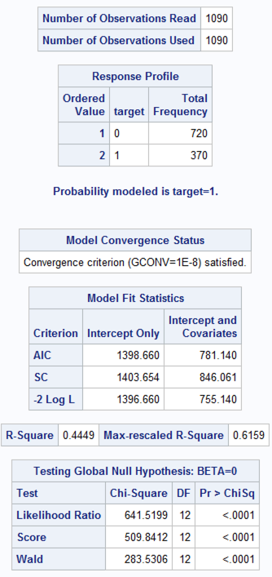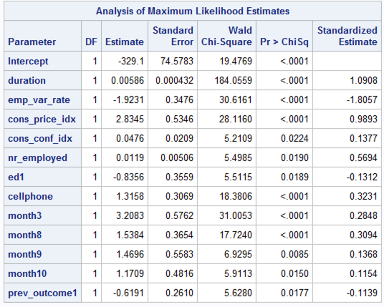

Next, we applied the ‘Backwards’ & ‘Stepwise’ methods to find a subset of optimal predictors.

|  |  |  |  |
| --- | --- | --- | --- |
|  | bank_small2 Full Model | bank_small2 Backwards (M7) | bank_small2 Stepwise (M8) |
| n | 1090 | 1090 | 1090 |
| k | 54 | 12 | 10 |
| RSQUARE | 0.4538 | 0.4449 | 0.4402 |
| AIC | 815.37 | 781.14 | 786.36 |
| SC | 1010.135 | 846 | 841.294 |
| LR | 659.29 | 641.5 | 632.299 |

The backwards selection method returned the best statistics of the 2 models, with the exception of SC value. Thus, we will choose the predictors selected by the Backwards selection method.

Next, we determine if there are any multi-collinearity issues among the independent variables chosen.

CONS_PRICE_IDX & EMP_VAR_RATE have a correlation value of -0.95

NR_EMPOLYED & CONS_PRICE_IDX 0.91

EMP_VAR_RATE & CONS_PRICE_IDX 0.96

Since the number of employees variable has one of the highest non-significant p-value (0.019), & is a quarterly indicator, we will remove that one and rerun our model.

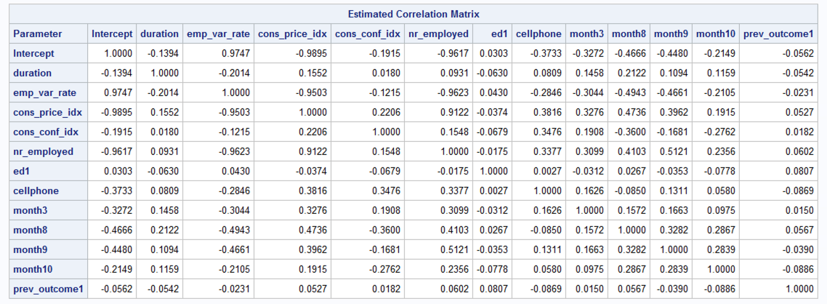

Only the SC value improved, but at least we no longer have a correlation value >.9 amongst our selected predictors:

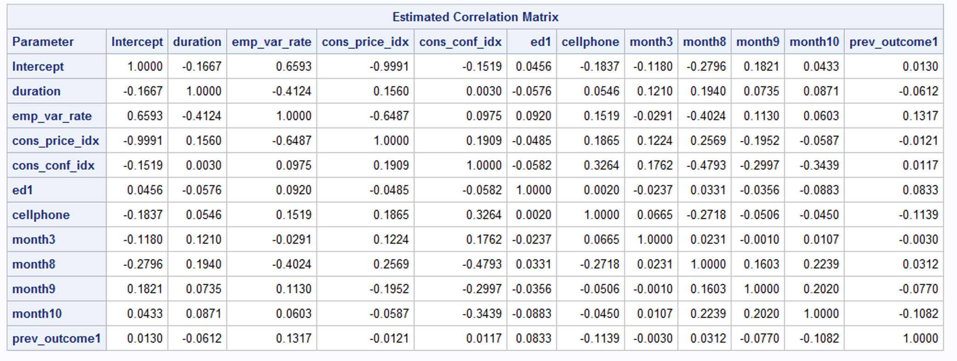

Next, we checked the Pearson & Deviance Residuals to see if there were any outliers we need to remove. According to our plot, outliers exist around observations:

Observations: 1082, 1045, 418, 320, 318, 261, 248, 230, 26, 66, 11

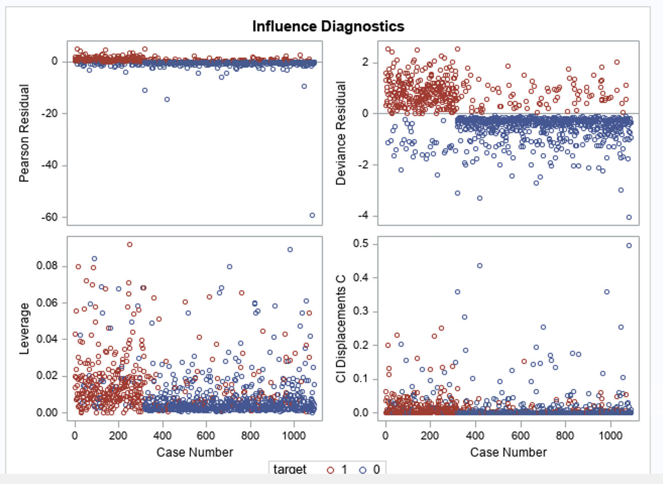

All the model statistics improved after removing those outliers:

|  |  |  |
| --- | --- | --- |
|  | before | after (removed outliers) |
| n | 1090 | 1079 |
| k | 11 | 11 |
| RSQUARE | 0.4421 | 0.4843 |
| AIC | 784.6 | 690 |
| SC | 844.57 | 750 |
| LR | 636 | 714.5 |

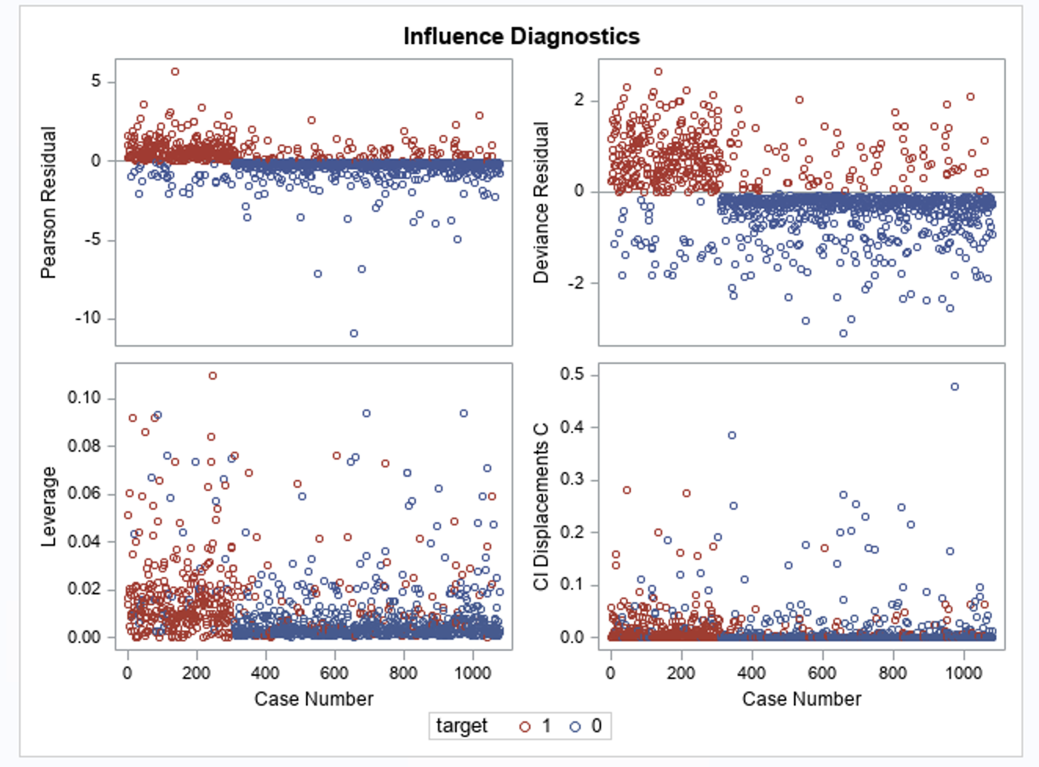

There are a few more to remove.

Observations: 938, 892, 848, 679, 658, 639, 551, 500, 136

Improved our model again:

|  |  |  |
| --- | --- | --- |
|  | M10 (removed outliers) | M11 (removed more outliers) |
| n | 1079 | 1070 |
| k | 11 | 11 |
| RSQUARE | 0.4843 | 0.51 |
| AIC | 690 | 623 |
| SC | 750 | 682.95 |
| LR | 714.5 | 772.8 |

Of course new outliers arose, but I think this is alright for now.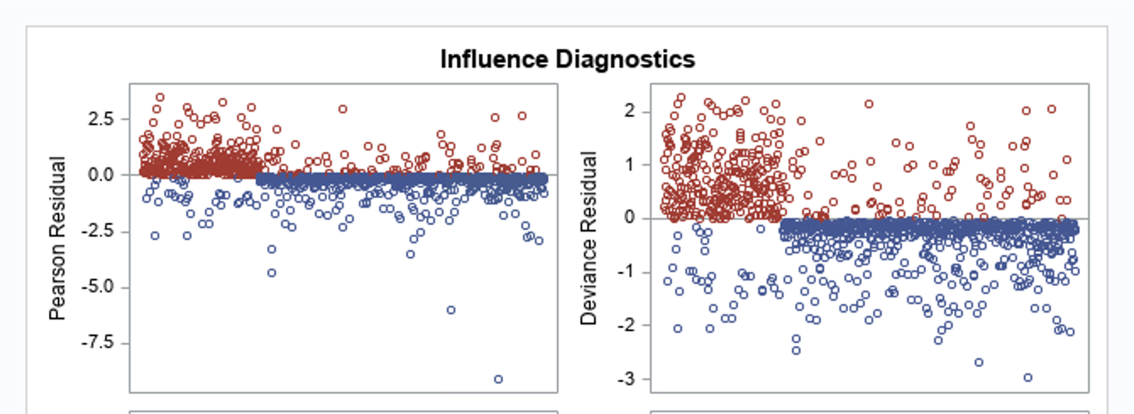

VALIDATION

|  |  |  |  |
| --- | --- | --- | --- |
|  | M11 (all data) | M12 (stepwise on training set) | M13 (backwards on training set) |
| n | 1070 | 642? |  |
| k | 11 | 7 | 10 |
| RSQUARE | 0.51 | 0.53 | 0.5377 |
| AIC | 623 | 360 | 355.86 |
| SC | 682.95 | 395.78 | 405 |
| LR | 772.8 | 485 | 495.3 |

As we can see here, the statistics measuring which model is best are pretty close. We will select M12 as our final model since it has less predictors with about as equal of accuracy.

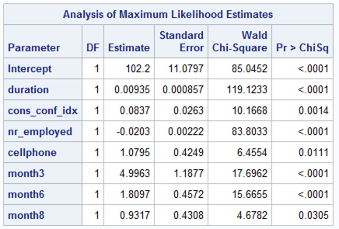

Next, we split our data into training & testing set. We’ll use a 60/40 split. This dataset, after cleaning, contains 1070 total observations, 364 of which are Y=1. The probability of getting y in the entire test set is P(Y=1/N) = 364/1070 = 0.34 = 34%. That will be our cutoff/threshold value.

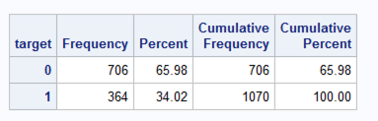

We have 706 samples of 'no' = 65.98% Probability, and 364 samples of 'yes' = 34.02% Probability.

odds(y=1) = 0.34/0.66 => The odds that event Y = 1 occurs is 0.515 to 1. This means we have a higher chance of failure.

odds(y=0) = 0.66/0.34 => 1.94 to 1 Higher chance of failure. (slide 8 of lecture 7)

Computing the predicted probability on SAS confirmed that the range 0.34-0.35 was optimal for getting the highest combined score of sensitivity & specificity (see ‘*ClassificationTable’* tab in ModelMetrics.xlxs).

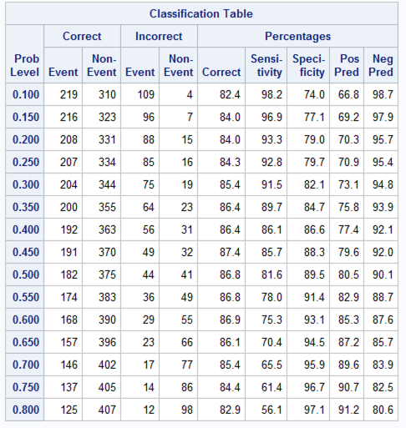

**Sensitivity or Recall** is the percentage of total relevant results correctly classified by the model. TP/(TP+FN) = 120/(120+21) ≈ 0.851 = 85.1%

**Accuracy** tells us how many predicted y’s were correct among all cases. (TP+TN)/(TP+TN+FN+FP) = (120 + 241)/(241+46+21+120) ≈ 0.843 = 84.3%

**Precision** is our “exactness”, or the amount of all the true positives against all the predicted positives. TP/(TP+FP) = 120/(120+46) ≈ 0.7229 = 72.3%

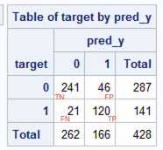

This model is able to predict true predictions for customers that’ll put in a deposit about 85.1% of the time.

For the final model

1. Write down the likelihood ratio test (null hypothesis, statistic and p-value)

|  |  |
| --- | --- |
|  | M12 (stepwise on training set) |
| n | 642? |
| k | 7 |
| RSQUARE | 0.53 |
| AIC | 360 |
| SC | 395.78 |
| LR (H0) | 485 |
| p-value | <0.0001 |

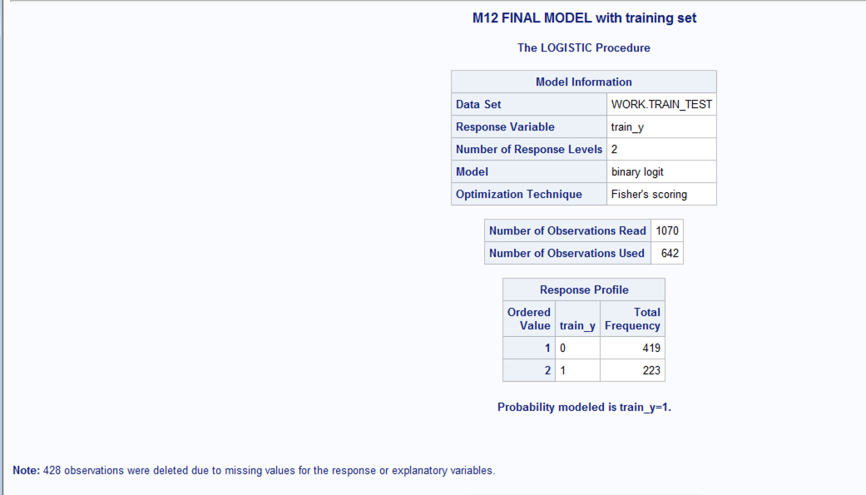

Note is regarding the test set, which have our null values in train_y variable to indicate test set.

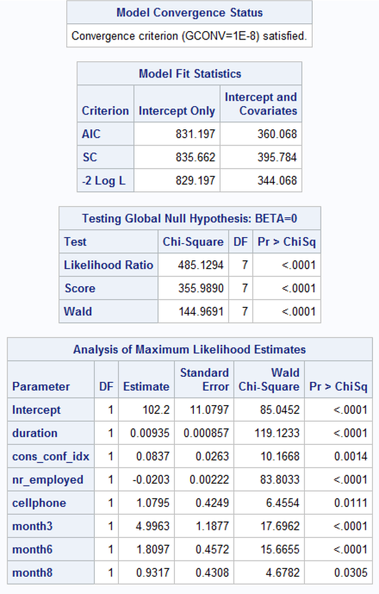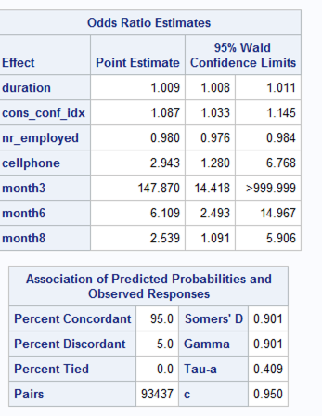

1. Write down the final model equation

log(target=1/target=0) = 102.2 + 0.009*DURATION + 0.08*CONS_CONF_IDX – 0.02*NR_EMPLOYED + 1.08*CELLPHONE + 5*MONTH3 + 1.8*MONTH6 + 0.9*MONTH8

Where cellphone=1 when contact='cellular',

cellphone=0 when contact=‘telephone’,

month3=1 when month='mar',

month6=1 when month='jun',

month8=1 when month='aug',

target=1 when y='yes'.

1. Analyze conditional effect of each variable on the odds of Y=1. Use coefficient values and the confidence intervals to explain your answer.